Name: _____________________________ Date:_________________
How did Florence Nightingale help the soldiers?
Draw a line to match the problem to the solution. Colour the pictures.
Problem:  The hospitals didn’t have enough supplies to look after the soldiers. |  | 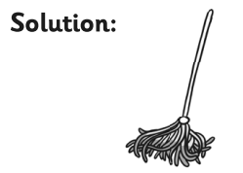
Problem:  The soldiers didn’t have enough food. |  | 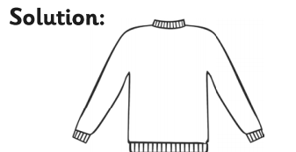
Problem:  The hospitals didn’t have enough medicine and bandages. |  | 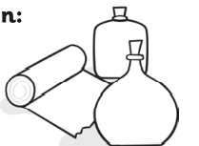  Solution:
Problem:  The soldiers weren’t looked after very well. |  | 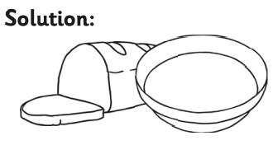
Problem:  The soldiers didn’t have clean clothes. |  | 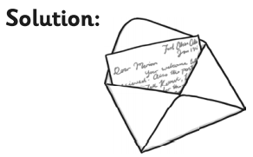
Problem:  The hospitals were very dirty. |  | 